Dear Friends,

Happy New Year! As we reflect on the past few months, we are filled with gratitude and excitement for everything we’ve accomplished together. The 10th Annual Dining in the Dark Gala was a tremendous success, raising significant funds to support our mission of empowering our blind and visually impaired community. The evening was filled with surprises, memorable moments, and incredible generosity from everyone who attended. Thank you for making it our best gala yet!

Our holiday celebrations were equally heartwarming. The Kids Holiday Party was a magical ice-skating event that brought so much joy to the children and their families. Watching their smiles and laughter was truly priceless. For our adult clients, the Holiday Party at Galuppi’s was a standout success. The event featured fantastic music, dancing, delicious food, and raffles. It was a wonderful way to wrap up the year.

We’re also excited to share some updates about our growing team here at Lighthouse of Broward. Please join us in welcoming Skyler McKay, our new Comprehensive Campaign Coordinator, Jose Cintron, our new AT (Assistive Technology) Instructor, Morgan Roush, our new Job Coach, and Ana Vallejo, our new Teacher of the Visually Impaired. Each of these talented individuals brings unique skills and dedication to our team, and we are excited to see the positive impact they will have on our community.

A Special Success Story: Horacio Martinez
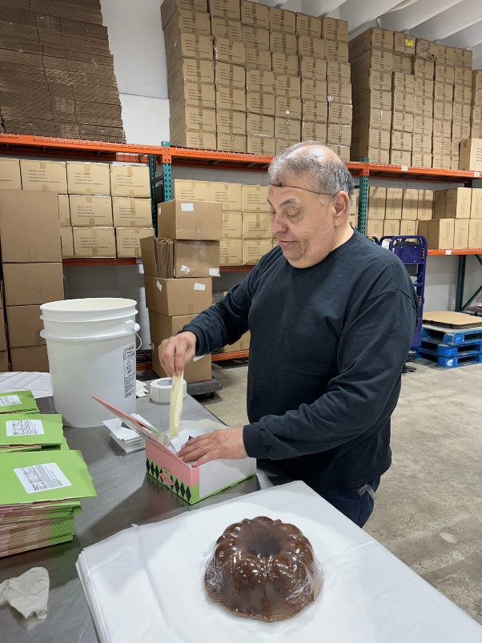
We are delighted to feature a very special recent success story of our incredible client, Horacio Martinez. Horacio’s journey is a testament to the power of perseverance and the transformative programs at Lighthouse of Broward.

Horacio lost his vision in 2014, and after facing the challenges that came with this life change, he joined Lighthouse of Broward to regain independence and build his career. Through our comprehensive training programs, he developed essential skills in adaptive daily living and assistive technology.

Horacio’s case manager, Saely Quezada, and his job coach, Rebecca Feingold, worked closely with him to ensure he was ready for work. His first opportunity came at the Sawgrass Nature Center, where he completed an eight-week work experience. Although that did not turn into full-time employment, Rebecca’s persistence led to a new opportunity with We Take the Cake, a local wholesale bakery. The CEO, whose father is visually impaired, was eager to meet Horacio and explore how he could contribute.

After an impressive interview and 12-week work experience, Horacio was offered part-time employment. His role at the bakery involves packaging cakes, labeling products, and preparing them for delivery to stores like BJ's and Costco. Horacio’s positive attitude, excellent work ethic, and willingness to take on new tasks have made him a valued member of the team.

Horacio’s story is a shining example of how the right support and training can unlock incredible potential. We are so proud of his accomplishments and excited to see where his journey takes him next.
Thank you for your continued support and dedication to our mission. We’re looking forward to an incredible year ahead, filled with new opportunities, connections, and successes!

With Gratitude,

Ellyn Drotzer, MSW, LCSW
President and CEO

Important Building Closure Dates & Updates
- LHOB Closed for New Years Day, Wednesday, January 1, 2025.
- LHOB Closed for Dr. Martin Luther King Jr. Day, Monday, January 20, 2025.
- LHOB Closed for President’s Day, Monday, February 17, 2025.
LHOB Social Groups and Activities: For all events you must RSVP in advance as space is limited.

Monthly Activities

Zumba Class: Every Friday 12:30 pm – 1:45 pm except February 14th and March 7th. Join us for a fun and energetic Zumba class that combines dance and fitness! This class features high-energy music and dynamic dance moves that provide an excellent cardio workout while improving coordination and rhythm. While most of the movements can be adapted for a seated position, there will also be some standing routines to elevate your heart rate and boost your mood. Whether you’re a seasoned dancer or a beginner, this class is designed for everyone to enjoy!

Arts & Crafts: Every Thursday 1:00-3:00p.m. Join us for adapted arts and crafts projects including painting with tactile lines, clay work, sewing, and floral arrangements. Activities vary each week. Space is limited, you must RSVP.

Book Club will meet on the last Friday of every month from 10:00 a.m. – 12:00 p.m. For more information, please contact the front desk at ext. 110.
January 31st – The Boys in the Boat, by Daniel James Brown, 17.24, Narrative Nonfiction, DB 77138

February 28th – Water for Elephants, by Sara Gruen, 12.44, Historical Fiction, DB 62718
March 28th – The Things We Do for Love, by Kristin Hannah, 13.3, Fiction, DB 116672

Trivia Group: January 10th and February 7th from 10am-12pm. When raucous laughter is heard in the halls of the Lighthouse, you can be sure it’s coming from the trivia group. Questions on a variety of subjects are read by a volunteer, and anyone who thinks they have the answer is free to call it out. Please RSVP at 954-463-4217 ext. 110.

BINGO: January 17th & 24th, February 21st, March 14th & 21st from 10:00 a.m. – 12:00 p.m. Join us for Bingo with Brailed cards and large print cards. There are prizes for the winners.

In-Person Problem Solvers Support Group for past clients with Dr. Alan Katell: Thursday, January 16th, February 13th, March 13th from 11:00am – 12:00pm. This support group offers a space for past clients to connect with others who have similar experiences. Instructors lead discussions on relevant topics and challenges that members with visual impairments may be encountering. This group provides an opportunity for individuals to share their experiences, insights, and strategies, fostering a supportive environment where members can exchange ideas, offer mutual encouragement, and work together to find effective solutions.

Descriptive movies: Join us on select Thursdays for a movie, popcorn, and treats. The movies will be shown in Classroom Two from 10:00am – 12:00pm.
January 9th – Murder Myster 2 (English): Full-time detectives Nick and Audrey are struggling to get their private eye agency off the ground. They find themselves at the center of international abduction when their friend Maharaja is kidnapped at his own lavish wedding.
January 23rd – Red Notice (Spanish): An Interpol agent successfully tracks down the world's most wanted art thief with help from a rival thief. But nothing is as it seems like a series of double-crosses ensues.
February 6th – Mr. & Mrs. Smith (English): Married life in the suburbs turns from lethally dull to just lethal when John and Jane Smith discover they’re both undercover assassins.
February 20th – Unfrosted (Spanish): In 1963 Michigan, business rivals Kellogg's and Post compete to create a cake that could change breakfast forever.
March 6th – Little (English): A woman is transformed into her younger self at a point in her life when the pressures of adulthood become too much to bear.
March 20th – Damsel (Spanish): A dutiful damsel agrees to marry a handsome prince, only to find the royal family has recruited her as a sacrifice to repay an ancient debt.

Support for Past and Present LHOB Clients:
Every Wednesday from 1:00-2:00. This support group is to help participants who want to connect with other individuals who are visually impaired. Instructors will discuss strategies for dealing with stress and anxiety. Members of this group can connect; share their experiences, coping strategies, and their strength and hope.
Join the call: https://www.uberconference.com/room/lhobsupport
Optional dial-in number: 954-451-0380
No PIN needed.
International Access Numbers:
https://www.uberconference.com/international
For more information, contact Carrie McKenna 954-463-4217 ext. 138 or cmckenna@LHOB.org.
Special Events for Past and Current LHOB Clients:
Flamingo Gardens Tour: Friday, February 14th from 10:30am – 2:30pm at Flamingo Gardens (3750 S Flamingo Rd, Davie, FL 33330). There will be a special sensory tour, time to explore, socialize, and enjoy the gardens. Boxed lunch is included for clients. Choice of ham and cheese, turkey and cheese, or veggie sub. No substitutions. Clients are welcome to bring lunch. Event is open to current and past clients. RSVP by January 31st to Front Desk at 954-463-4217 ext. 110. Space is limited.
Client Resource Fair: Friday, March 7th from 10:00am – 2:00pm at Flamingo Hall (12855 NW 8th St, Sunrise, FL 33323). There will be community resources, followed by lunch. Choice of ham and cheese, turkey and cheese, or veggie sub. No substitutions. Clients are welcome to bring lunch. Clients must call to reserve their spot. RSVP by February 21st by calling the front desk 954-463-4217 ext. 110.
Drumming Circle: Thursday, March 27th from 12:00pm – 1:00pm. RSVP by calling the front desk 954-463-4217 ext. 110. Space is limited to the first 14 participants who sign up.

